SOUVENIR BOOK AD FORM

**Tabernacle of Faith Church, Inc.**

**Church of God in Christ**

115 North 5th Street, Camden. NJ 08102

Bishop Tyrone W. McCombs, Ph.D., Pastor

To commemorate the celebration of the 50th Church Anniversary of Tabernacle of Faith Church, a souvenir book will be published. We are requesting your support for this historic endeavor.

Please print or type the information below:  
**Name of Advertiser (Church/Business/Individual):** __________________________________

**Contact person**: __________________________ **Email:** _______________________________

**Telephone number**: ___________________________

All Monies and Ads must be **received by Sunday, March 31, 2024** Please send **Camera- Ready Artwork/Layouts for Ads** you wish to be displayed in the book. You may email your ads to taboffaithoffice@gmail.com.

Souvenir Booklet Ad Dimensions

The dimensions below reflect the sizes of the ad page sizes available for purchase.

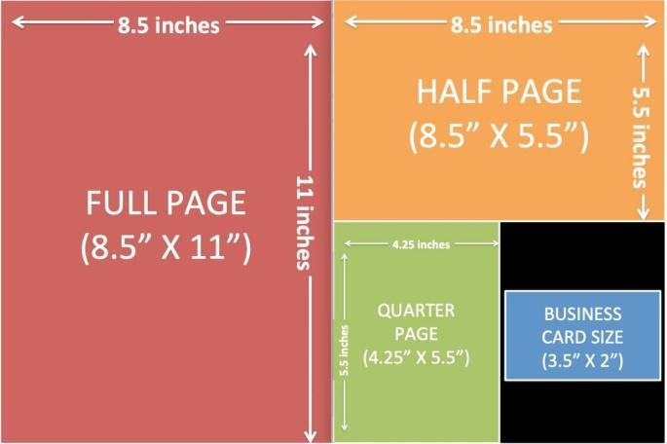

Check one box below for your ad size:

Full Page $100.00 Half Page $75.00 Quarter Page $50.00 Eighth page $30.00 Patron $20.00

1. Print ready ads should be submitted using the following specs:  
   Full Page (8.5x11), Half Page (8x5.125), Quarter Page (3.625x4.55), Business Card (2.25x3.5).
2. Ad must be typed exactly as it is to appear in the Souvenir Booklet, and submitted via Word document.
3. You may wish to use one of the following fonts for your ad copy: Bookman, Courier, or Times Roman.
4. Black and white or color photographs accepted
5. Ad measurements are based on 8 by 11-page size.
6. Photographs can be submitted in digital format. Hard copies will be accepted.
7. FILE FORMATS ACCEPTED: PDF or JPEG
8. To ensure the highest print quality, please submit high resolution images.
9. Check must be received by deadline for ad to be included.

Make check payable to: Tabernacle of Faith Church

Mail Ad and Payment to: Tabernacle of Faith Church

(Deadline date for ad 115 N. 5th Street

Is March 31, 2024) Camden, NJ 08102

Questions and ads may be emailed to (taboffaithoffice@gmail.com) or 609-352-6704.

FOR COMMITTEE USE ONLY:

|  |  |  |  |
| --- | --- | --- | --- |
| Form of Payment: | Date Received: | Received by (Initials): |  |
| Amount Received: | Ad Size : Full, Half, Quarter, Business, Patron | Photo: Yes or No | Type of Picture: B/W or Color |
| Description: | | | |

page3image983247680page3image983248112